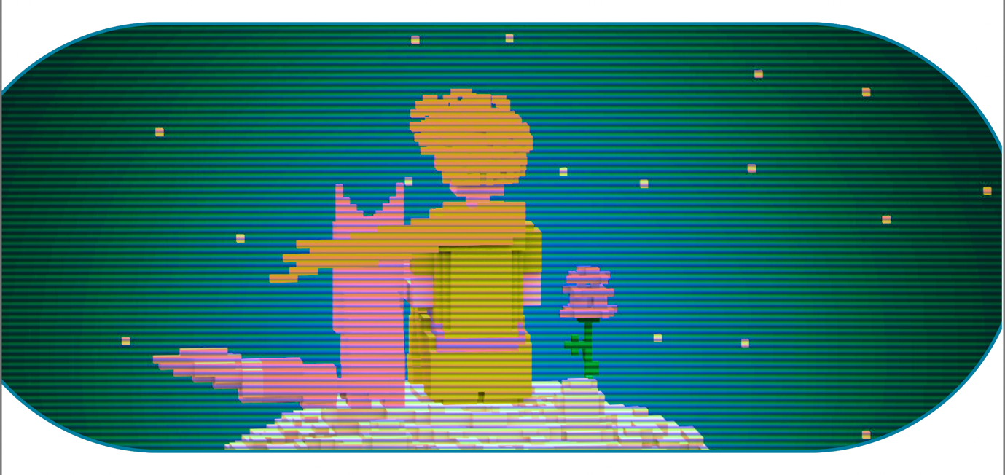
CALL FOR ARTISTIC RESEARCH RESIDENCIES IN XR
https://xr2c2.univ-cotedazur.fr
This residence benefits from aid from the French government, managed by the National Research Agency under the Investissements d'Avenir UCAJEDI project, reference number ANR-15-IDEX-01.

1- About the XR²C² residency
1.1 - Presentation. Created in 2020, at the impetus of Université Côte d'Azur, one of the top research-intensive universities in France recognized by the Idex award (Initiative of excellence), the XR2C2 (eXtended Reality Research and Creation Center) reference center oversees the multi-disciplinary actions of 13 UCA laboratories in the field of Extended Reality (or XR). It coordinates research activities focusing on new media carried out on the new Cannes campus and collaborates with the various consortiums in the Cultural and Creative Industries in which UCA participates.
Open to all types of extended reality experiences (virtual, augmented and mixed), the XR2X2 residency is a new program dedicated to immersive creation. Its objective is to allow a creator - whatever his or her status - to develop a research project in art and creation in the field of immersivity. The residency will also serve to strengthen the links between the different disciplines represented in the reference center (computer science, signal processing, narratology, arts and humanities, history, media studies, health, cognition, music, theater, and dance), and with doctoral students and post-doctoral fellows working in XR2C2's partner laboratories (INRIA, I3S, SICLAB, CObTEK, CTELA, LIRCES, CEPAM, CMMC, Nice Conservatory, LAPCOS, CIRM, LAMHESS, GREDEG, ICN Business School Artem, CEPAM, UR2CA-Unité de Recherche Clinique Côte d'Azur, Nice University Hospital, and RETINES). Its purpose is also to create new synergies with the cultural and entrepreneurial sector of the Université Côte d'Azur region.

1.2 - Objectives
The residency will take place in Cannes, on the Georges Méliès Campus dedicated to education and innovation.
At the end of the residency, the creator will be asked to submit a report on the residency experience, work and progress during this period. The project must also be presented as a conference / master class, where the creator will describe the preliminary questions, problems encountered and proposed solutions. The selected creator will be given the opportunity to take part in different events (festivals, international conferences, etc.).

1.3 - Benefits
- 8 to 12 weeks of residency on the Georges Méliès Campus in Cannes.
- Between 3,000 and 6,000 euros depending on the length of the residency, the type of residency and the project selected.
- Access to technical platforms.
- Accommodation (studio apartment): subject to availability, accommodation is provided in the CROUS residence hall located on the Campus Méliès.
-Travel to and from the residency could be compensated depending on the creator’s status and upon presentation of receipts, subject to public procurement rules. A production budget may be made available, depending on the project, for the purchase of additional equipment (which will remain the property of XR2C2).
-The acquisition of a version / variation of the project by XR2C2 (pre-purchase: amount to be determined).

2- Conditions of eligibility
2.1 - Profile of applicants.
- Artist, creator or leader of an XR project in development.
- Confirmed professional with previous experience in the field of XR.
- Experienced researcher with previous experience in the field of XR.

2.2 - Accepted projects. This program is open to any type of XR project (virtual, augmented or mixed reality, immersive installations, 360 technologies, live performance and production).

2.3 - Selection criteria
The selection committee will examine the applications according to the following criteria:
- Originality of the artistic and/or research concept(s) presented.
- Feasibility of the residency.
- Relevance of the proposal with the themes of XR²C².
- Autonomy of the artist as regards the main technical aspects of the project.

3.2 - Required information
- Professional status
- Copy of the ID card or passport (for French nationals)
or Copy of the resident card or work visa (for foreigners residing in France).
- Professional CV detailing the applicant’s qualifications and experience.
- Portfolio of previous projects.
- Letter of motivation.
- Letter of recommendation.
- Description of the creation research project using the template provided in the appendix.

4- Selection and commitments
4.1 - Selection committee
The scientific committee of XR2C2 will evaluate the eligible projects.

4.2 - Notification and official announcement
The name of the winner will be officially communicated by e-mail following the decision of the selection committee.

4.3 - Obligations of the winner
A residency contract summarizing all the commitments of both parties will be signed by the parties involved. Prior to the residency, the successful candidate undertakes to:
- Send to the partners an outline of the work planned during the residency (including any travel expected).
During the residency, the successful candidate commits:
- To meet and interact with the other researchers and artists of Université Côte d'Azur.
- To carry out the work planned.
- At the end of the residency, to share with the partners a report and a demonstration detailing the creative process and the results obtained.
Concerning the project, the successful candidate commits to:
- Finalize the project no later than June 30, 2027.
- Present the results of the work accomplished during the residency (prototype, work-in-progress) within the framework of XR2C2 activities.
- Include the logos requested by the partners in the project's credits and on all communication material.
- Authorize the residency partners to communicate or present the project for promotional purposes as part of their programmed activities.
5- Timeline
March 1st 2026: call for applications opens.
May 4th 2026: call for applications closes (midnight, GMT).
June 20th 2026: short-listed and unsuccessful candidates are notified.
June 20th – 30th 2026: online interviews with the short-listed candidates and notification of the winner.
The residency must be planned in one or several stays between September 1, 2026 and June 30, 2027, including a public residency presentation.
6- Contact
Send applications to: matteo.treleani@univ-cotedazur.fr and charles.meyer@univ-cotedazur.fr
Please contact us if you have any questions: maxence.mercier@univ-cotedazur.fr

APPLICATION TEMPLATE

CALL FOR ART-CREATION RESIDENCIES 2026

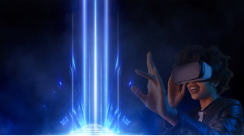

IDENTIFICATION

Last name and first name of the project leader responsible for the application:

E-mail of the project leader responsible for the application:

PROJECT

Title of the project:

Abstract (150 words):

Project Plan with timeline:

Technical rider:
(Materials, devices, space needs, etc.)

External Partners (yes/no):

External Partner #1:

External partner #2:

Description of the objectives of the residency, in terms of research question, approaches, methodologies, techniques (8 pages maximum with a descriptive appendix, if necessary):

Relevance to the main themes of XR2C2:

FUNDING

EXPENSES (excluding tax)
DESCRIPTION |  | AMOUNT
TOTAL EXPENSES
INCOME GRANTED |  | INCOME REQUESTED
ORIGIN | AMOUNT | ORIGIN | AMOUNT
TOTAL INCOME

